**LOOPS**

Python Modules: From Wed : 9.30 to 11 am

String and

Regular expression

Files

Debugging and Functions

Collections

OOPS

<2 years

Python with Django :

2+ Years

Python with Data Scientist

Python with Aws/Devops

Python with Big data Hadoop

>>> a = 24

>>> type(a)

<class 'int'>

>>> a = 'hello world '

>>> type(a)

<class 'str'>

>>> a = 4.5

>>> type(a)

<class 'float'>

>>>

>>> a = input('Enter value for a ')

Enter value for a 24

>>> a

'24'

>>> a = **int**(input('Enter value for a '))

Enter value for a 24

>>> a

24

>>>

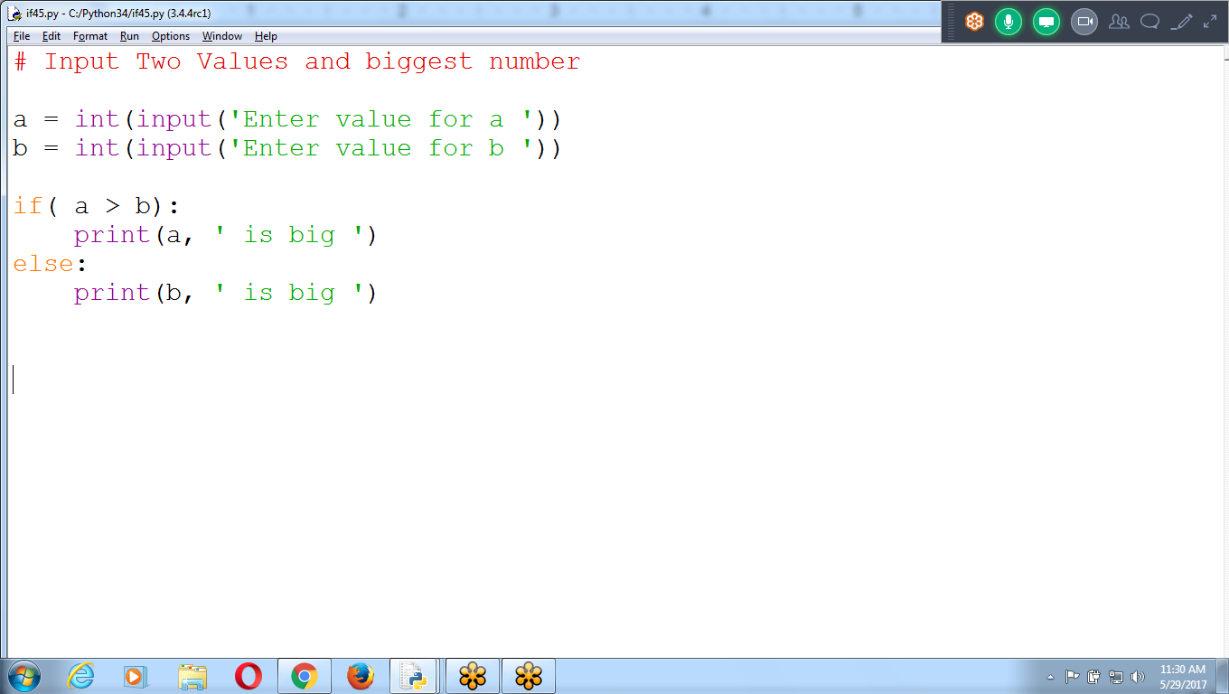

## 

## **For and while Loops and the range() Function**

* The while loop keeps looping while its condition is True
* To execute a block of code only a certain number of times?

Use for loop statement and the range() function.

for statement looks something like for i in range(5): and always includes the following:

* The for keyword
* A variable name
* The in keyword
* A call to the range() method with up to three integers passed to it
* A colon
* Starting on the next line, an indented block of code

### **The Starting, Stopping, and Stepping Arguments to range()**

The first argument will be where the for loop’s variable start, and the second argument will be up to, but not including.

The range() function can also be called with three arguments.

The first two arguments will be the start and stop values, and the **third** will be the *step argument*.

**# Loops**

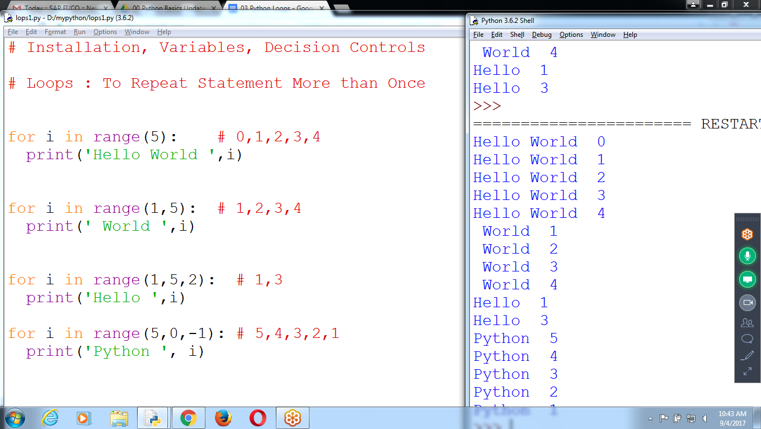

**# Installation, Variables, Decision Controls**

**# Loops : To Repeat Statement More than Once**

**for i in range(5): # 0,1,2,3,4**

**print('Hello World ',i)**

**for i in range(1,5): # 1,2,3,4**

**print(' World ',i)**

**for i in range(1,5,2): # 1,3**

**print('Hello ',i)**

**for i in range(5,0,-1): # 5,4,3,2,1**

**print('Python ', i)**

## 

## 

## **Display values from 1 to n using for and while**

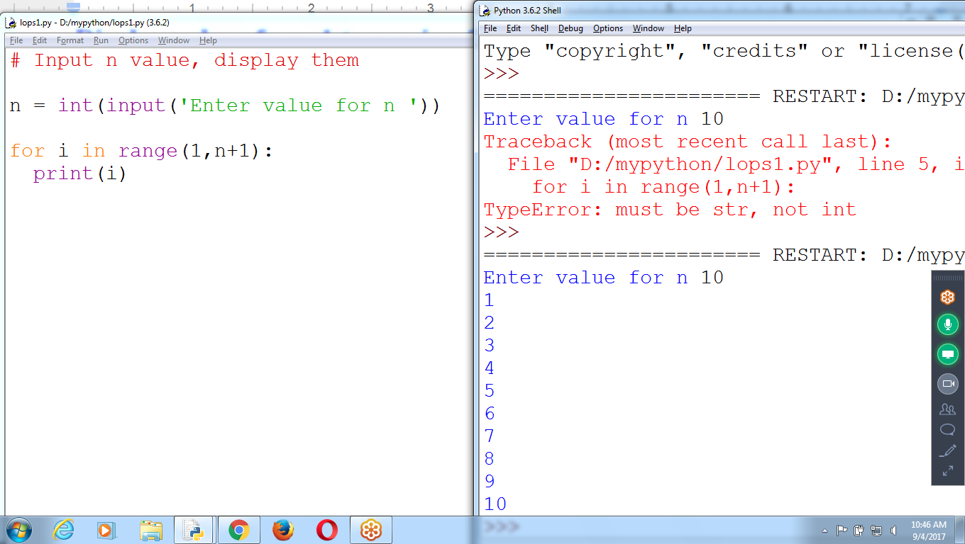

ERROR

N must be integer type

# To Print values from 1 to n

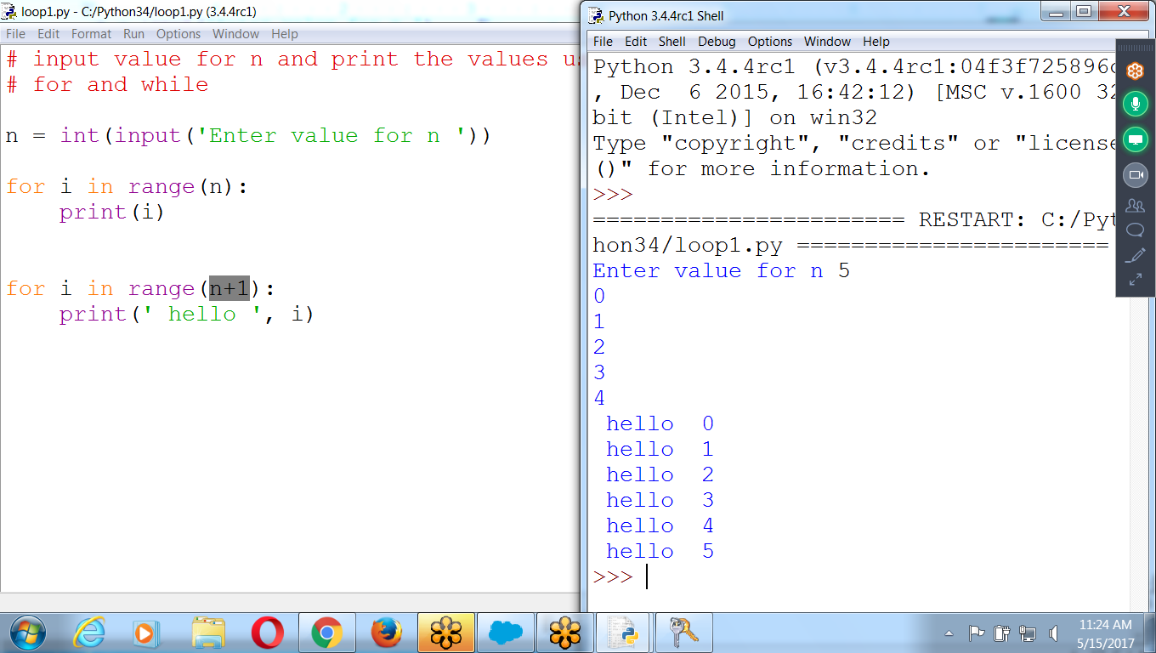

# INput Starting, ending and STepping values

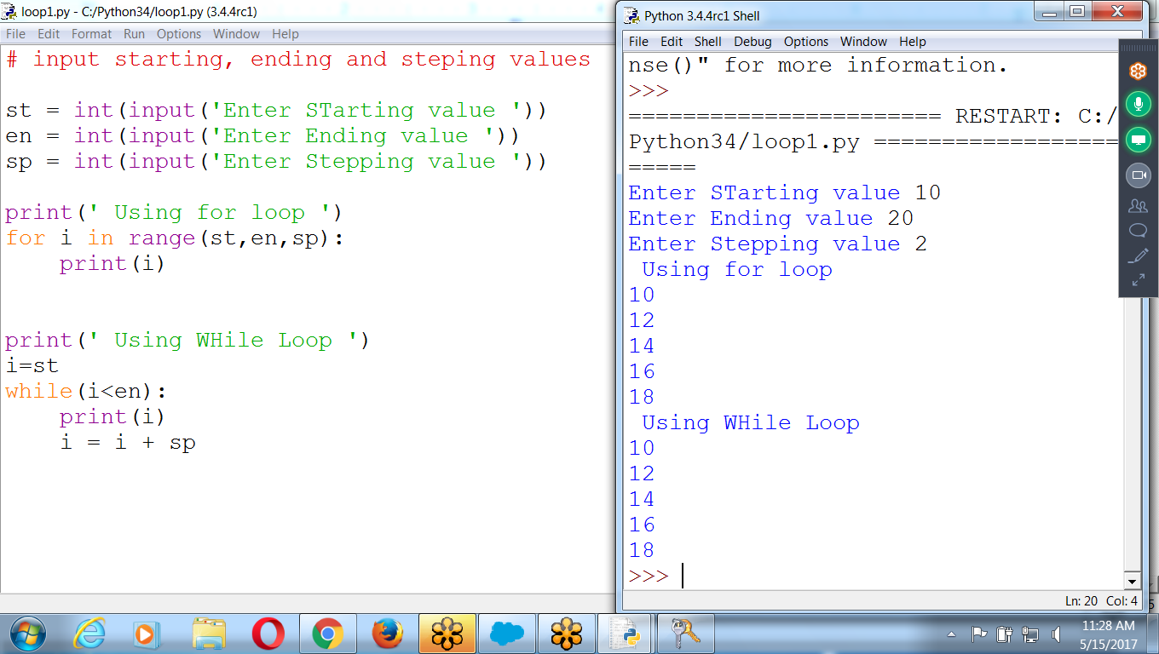

# input starting, ending and stepping values

st = int(input('Enter STarting value '))

en = int(input('Enter Ending value '))

sp = int(input('Enter Stepping value '))

print(' Using for loop ')

for i in range(st,en,sp):

print(i)

print(' Using WHile Loop ')

i=st

while(i<en):

print(i)

i = i + sp

**sum of all the numbers from 1 to n**

**n =5 ::: 1 + 2 + 3 + 4 + 5**

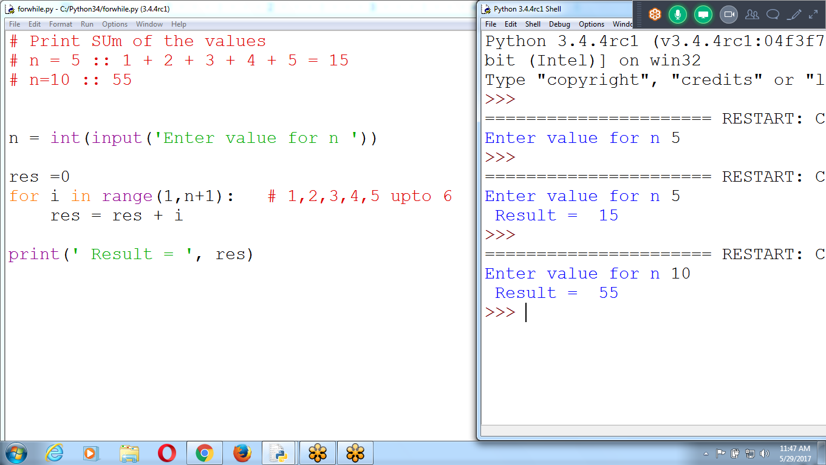

**# Print SUm of the values**

**# n = 5 :: 1 + 2 + 3 + 4 + 5 = 15**

**# n=10 :: 55**

**n = int(input('Enter value for n '))**

**res =0**

**for i in range(1,n+1): # 1,2,3,4,5 upto 6**

**res = res + i**

**print(' Result = ', res)**

**Print statement within the for loop**

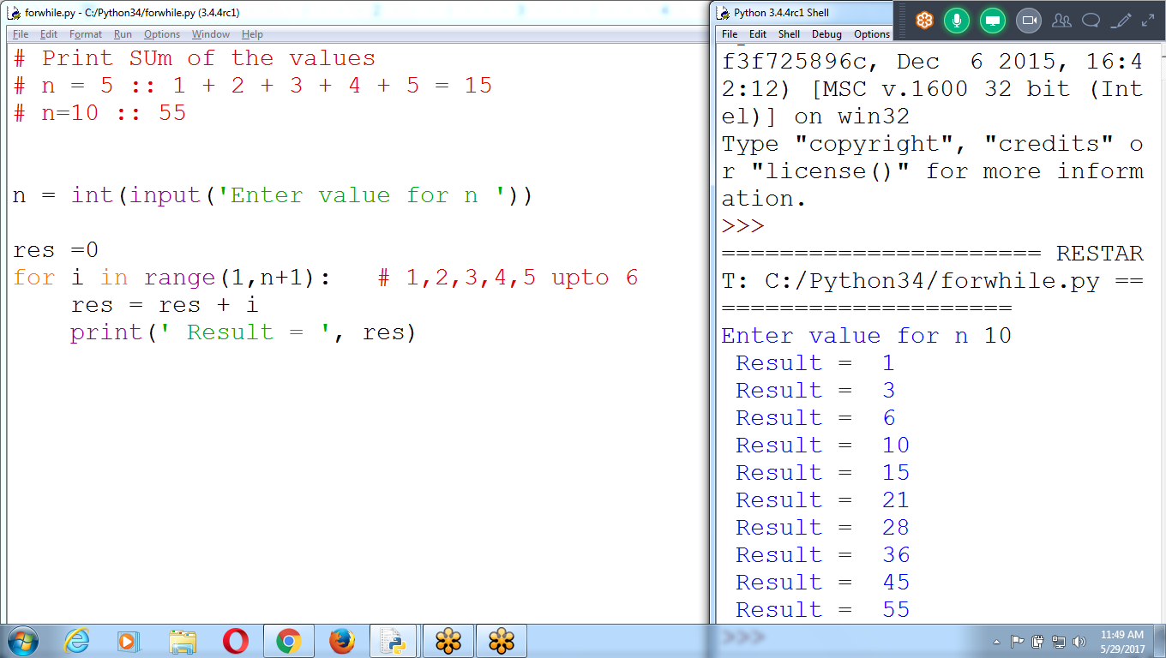

# **Remove space, place print outside the for loop**

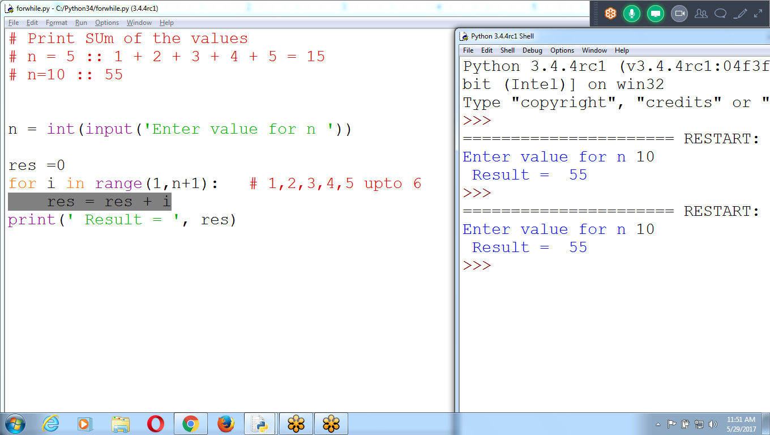

# 

# **Find Factorial of given number, Product of the values**

Res =1

Replace res = res * i

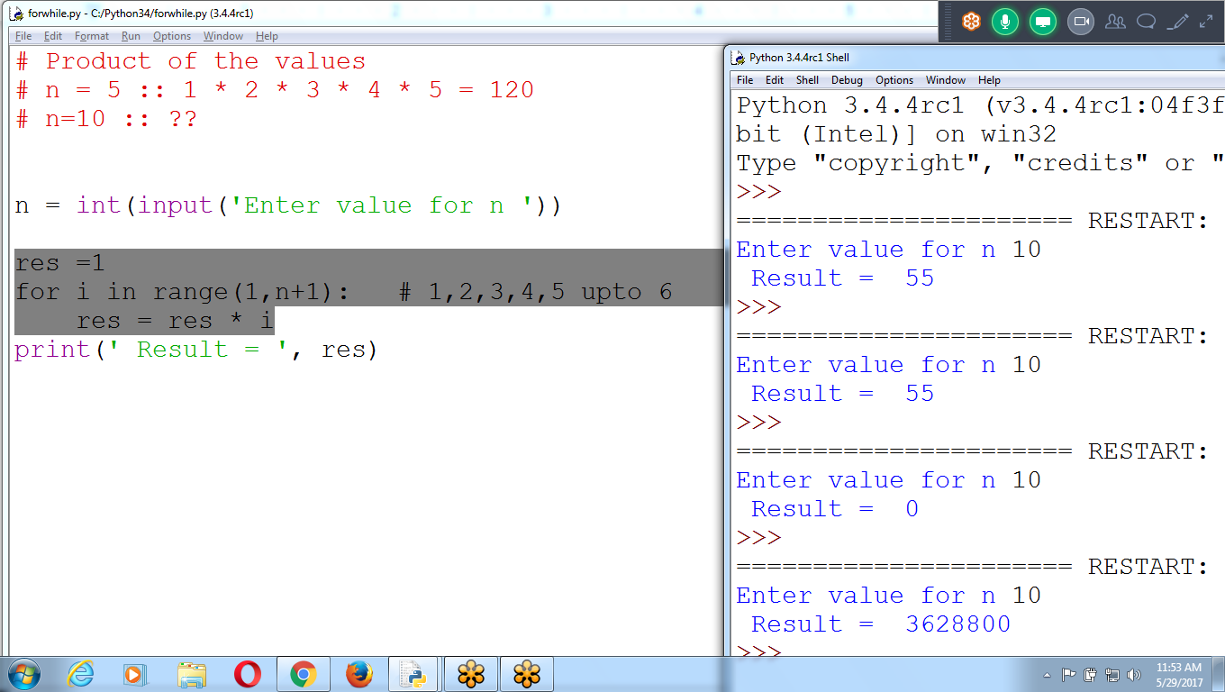

# Product of the values is Factorial of given number

# n = 5 :: 1 * 2 * 3 * 4 * 5 = 120

# n=10 :: ??

n = int(input('Enter value for n '))

res =1

for i in range(1,n+1): # 1,2,3,4,5 upto 6

res = res * i

print(' Result = ', res)

To Print Given Table Number

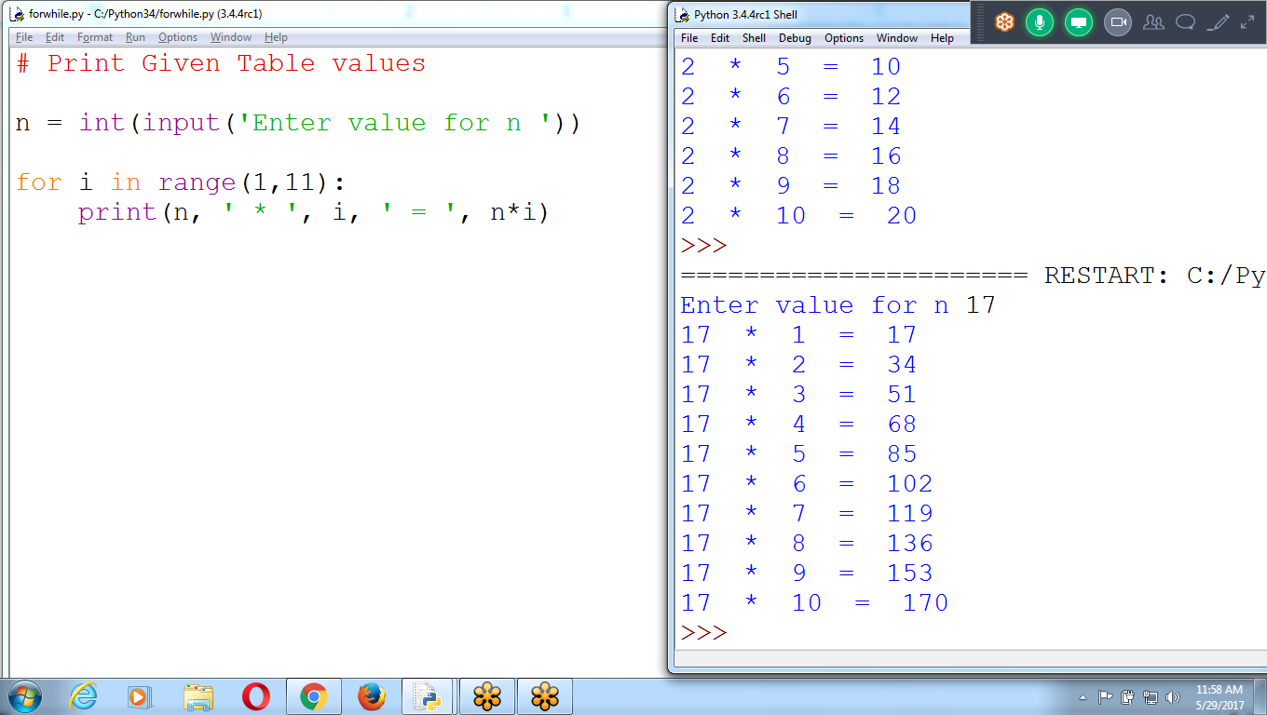

# Print Given Table number

# 2 * 1 = 2

# 2 * 2 = 4

n = int(input('Enter value for n '))

for i in range(1,11):

print(n, ' * ', i, ' = ', n*i)

Given Range of Tables using Nested Loop

Nested :: Loop within Loop

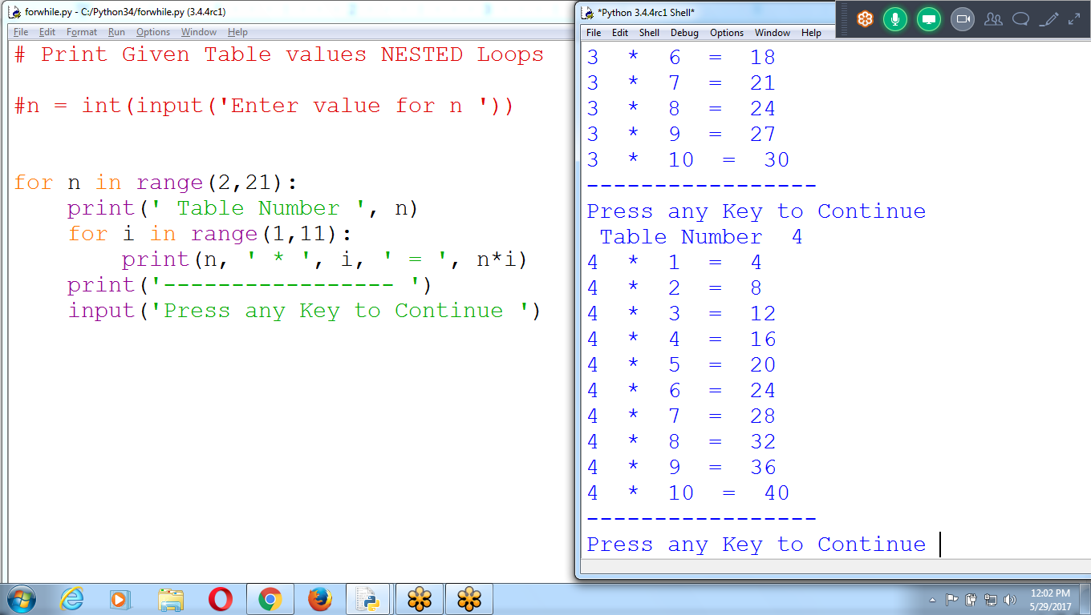

# Print Given Table values NESTED Loops

for n in range(2,21):

print(' Table Number ', n)

for i in range(1,11):

print(n, ' * ', i, ' = ', n*i)

print('----------------- ')

input('Press any Key to Continue ')

print() and input() are outside the Loop

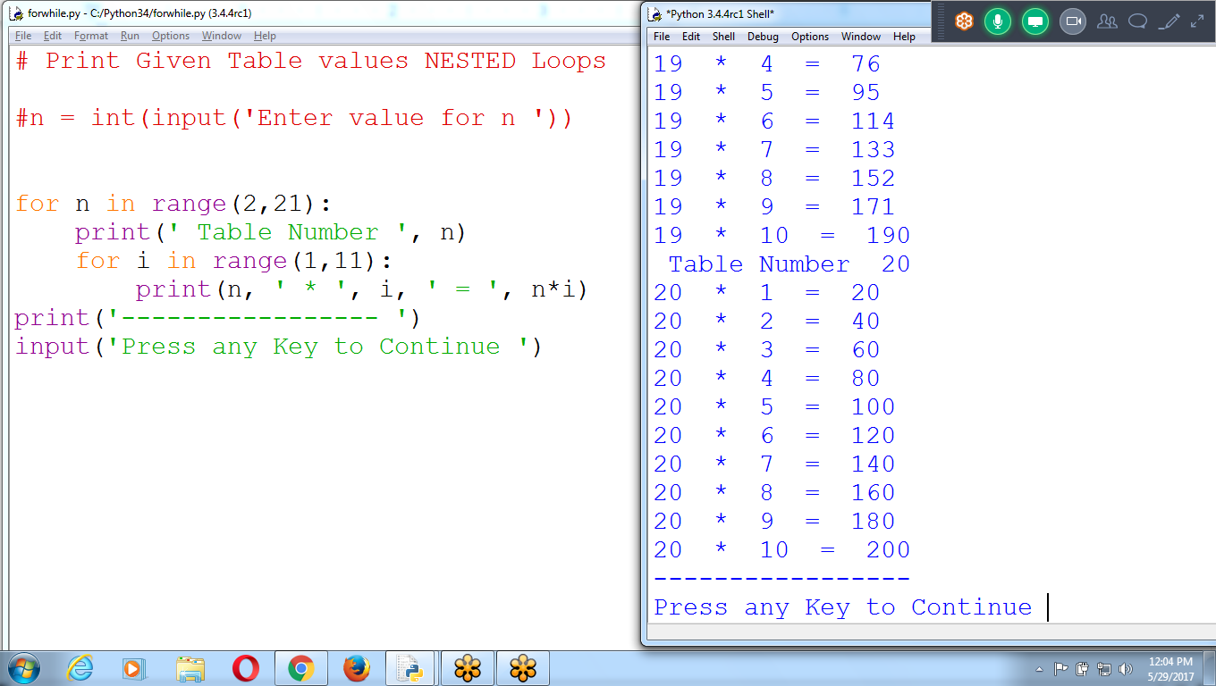

## **Break Statements**

If the execution reaches a **break statemen**t, it immediately exits the while loop’s clause.

* If you ever run a program that has a bug causing it to get stuck in an infinite loop, **press CTRL-C**. This will send a KeyboardInterrupt error to your program and cause it to **stop immediately**

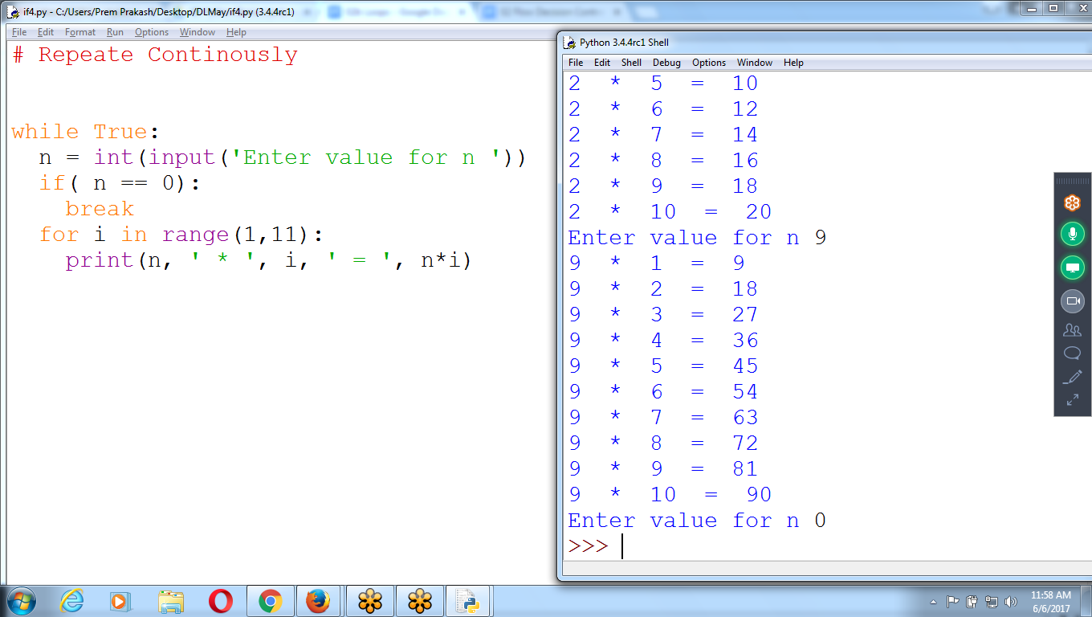

# Repeat Continuously

while True:

**n = int(input('Enter value for n '))**

if( n == 0):

break

for i in range(1,11):

print(n, ' * ', i, ' = ', n*i)

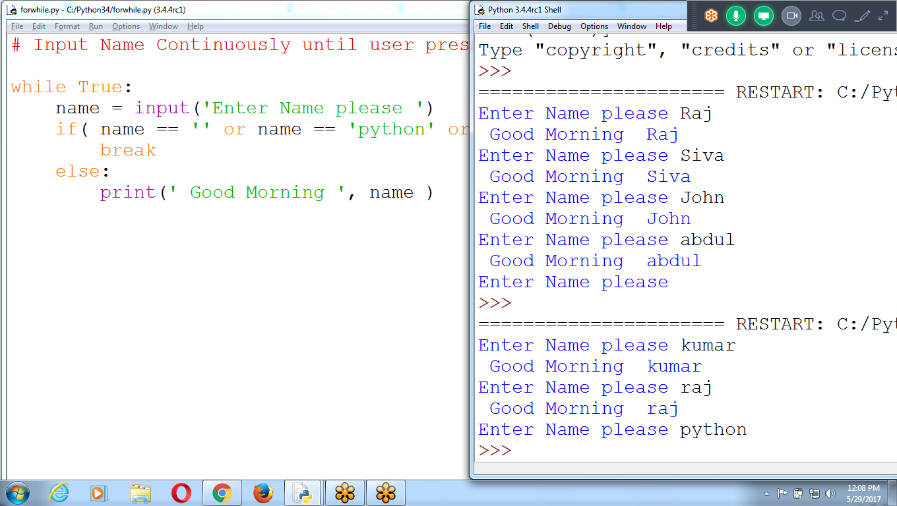

# Input Name Continuously until user press enter (or) python (or) bye

while True:

name = input('Enter Name please ')

if( name == '' or name == 'python' or name == 'bye'):

break

else:

print(' Good Morning ', name )

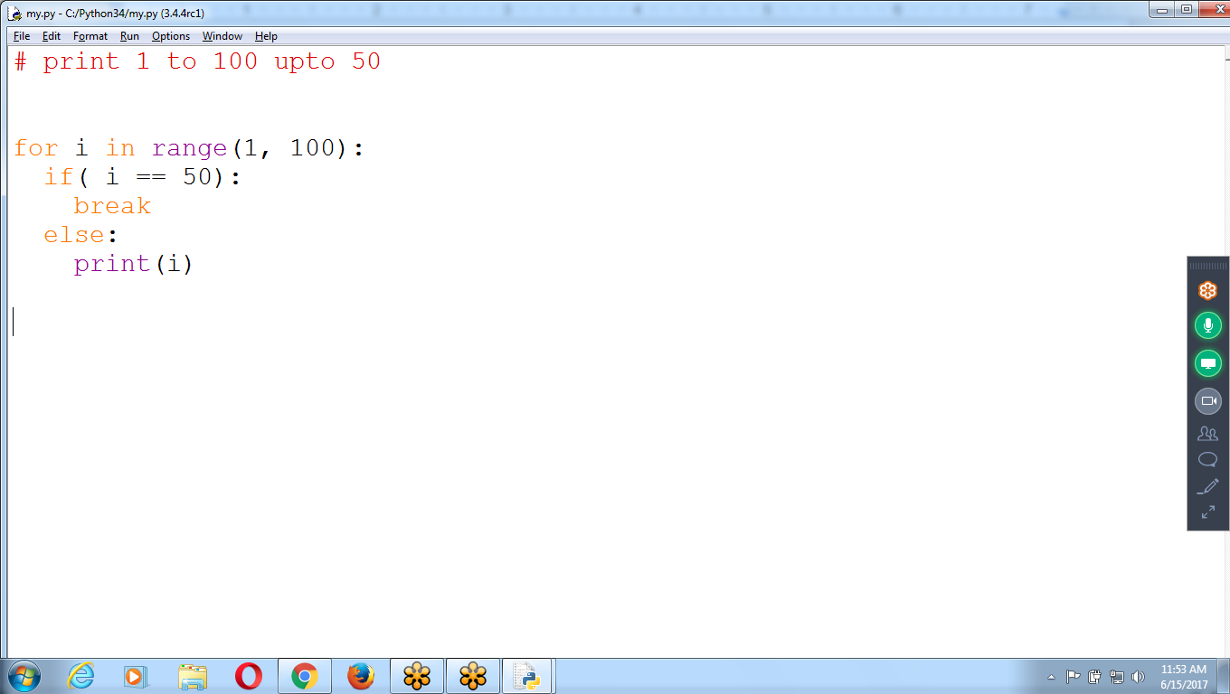

**Using Continue**

Skip statements between continue and end of the loop

**Continue for next Iteration**

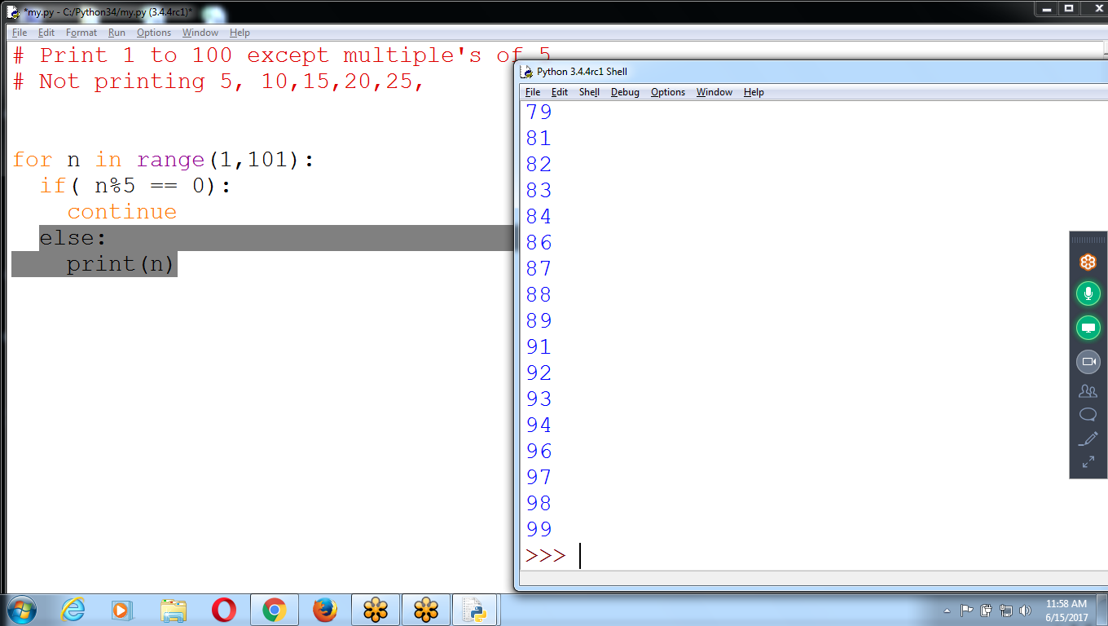

# Print 1 to 100 except multiple's of 5

# Not printing 5, 10,15,20,25,

for n in range(1,101):

if( n%5 == 0):

continue

else:

print(n)

Use break

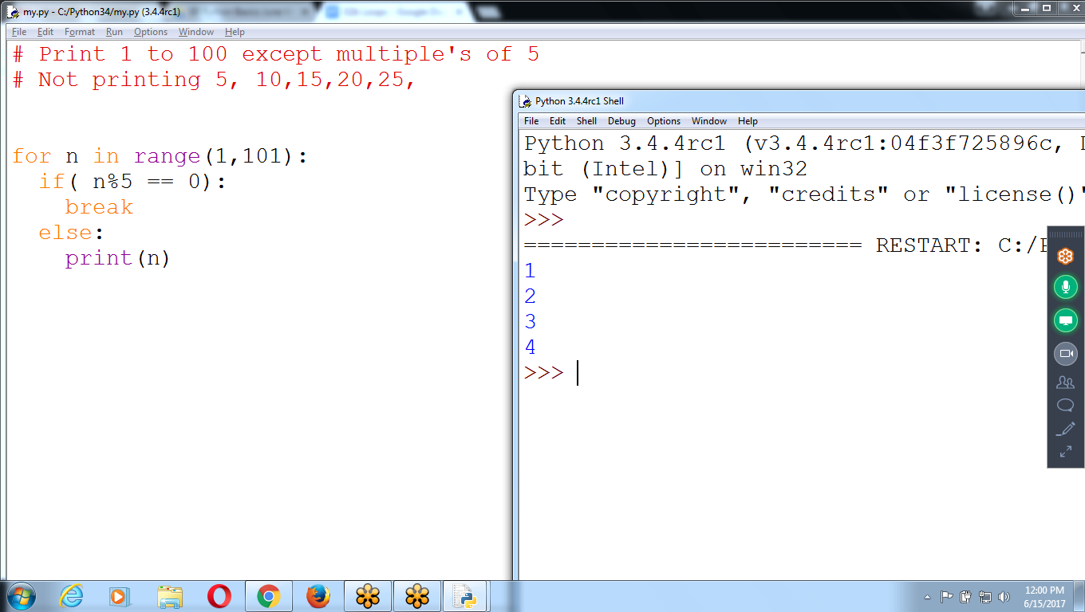

**Find Given Number is PRIME or not**

# 

# 

**Python Basics : 11.30 to 12.30 am**

**1 Installation, Expression, Data types, Variables,**

**Execution and Operators**

**2 Flow Controls (If, if-else) and**

**3 Loops for, while, Range( Examples)**

**4 Functions and**

**5 Collections( List, tuple, Dictionary)**

**PYTHON (30 Hours) : 9.30 to 10.30 am from Thursday**

**R Programing: 10.30 to 11.30 am**

**Python : Strings**

**Python : Regular Expressions**

**Python : Files**

**Python: Debugging, Exceptions**

**Python : Generators and Decorators**

**Python : Functions**

**Python : Collections (List, set , Dictionary)**

**python : OOPS**

**Advance Python ( 30 Hours)**

**Web, GUI, Database, Data Structures**

**Gaming, Multithreading, Numpy, scipy**

**Networking, Email, Scraping**

**Jupyter, Pycharm (EDITORS)**

**Python Developer :**

**Python (30 H) +**

**Advanced Python (30) + Python Projects**

**dJango (30 Hours) + Web Projects**

**Other Technologies :**

**Python (30 Hours) +**

**Data Science or AWS or**

**Devops or Big data or**

**Selenium or Open stack**

**Data Science : 3 Months (250 Hours)**

**Mon to Fri : 9.30 to 11.30**

**sat and sun :**

**Python + R Lang + Machine Learning ( 2 months)**

**Deep Learning + Natural Language Processing +**

**Predictive Analysis + Artificial Intelligence ( 2 Months)**